Solar Powered LP Gas Level Sensor
Using the Adafruit HUZZAH 32 ESP-32 microprocessor
Project #1 11/20/2021 – David Hoggard

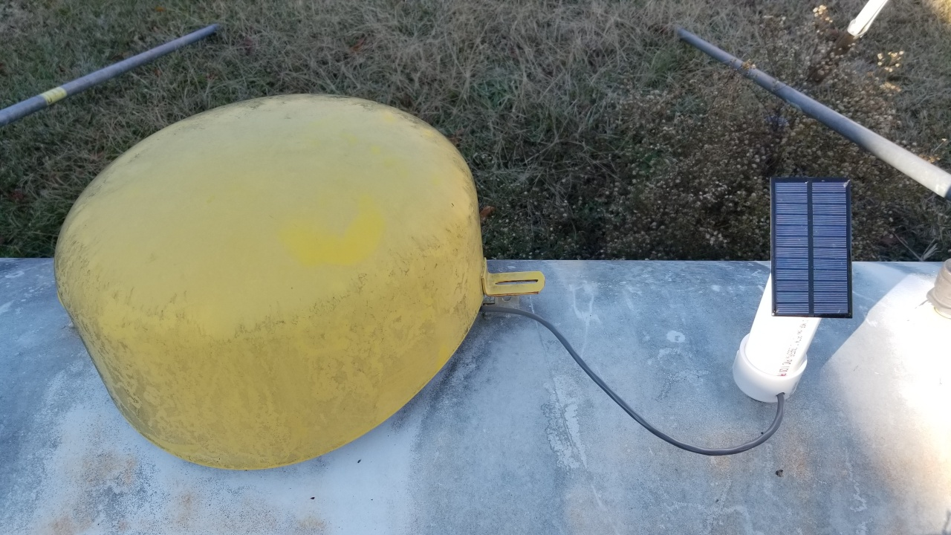

In looking for ways to utilize the various microprocessor boards that I have acquired over the years, I decided to build this solar powered LP Gas level sensor using an ESP32 microprocessor. This project would require the use of a battery to power the ESP32 and also solar power to recharge the battery. After watching many YouTube videos on solar powered projects, I purchased the needed components from Amazon and Ali express. I then started researching what code would be needed and outlined what I intended to achieve with this project. The main purpose of the project is to be able to monitor the LP gas level in the outside tank utilizing a sensor manufactured by Rochester. The model gauge is shown in this link; https://rochestergauges.com/product/jr-and-sr-r3d-dials-lp/
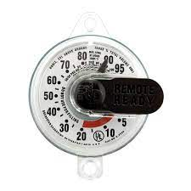

It works off of a hall effect sensor. The spec sheet states it works from 3.5 to 5 volts but It seems to work fine at a little lower voltage than that. It is a 3-wire device that has B+, ground, and an output voltage that is proportional to the gas level. We will measure this voltage using the ESP32 and map it to a percentage level, then transmit the data using mqtt to Home Assistant where we can do a number of things with the data. For instance, keep up with when the tank is filled, graph gas usage versus outside temperature versus inside temperature, get emails or text messages when the tank needs to be refilled, detect gas leakages in the summer months when no gas is being used.
Another design goal in this project was to use as small of a solar panel as possible. I purchased some that were rated at 6volts @ 1 watt. I seriously doubt that it will put out 1 watt as that would be 160ma. These were 4.3” x 2.4” in size.
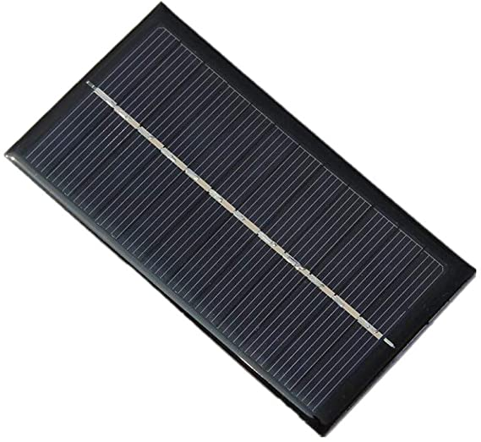

I then needed to be able to take this raw voltage and charge a battery. I chose the popular 18650 li-ion battery. This battery has a nominal 3.7v 4000mah, is fully charged at 4.1volts, and considered depleted at 2.9volts. And of course I needed a battery box for the battery, both available on Amazon.

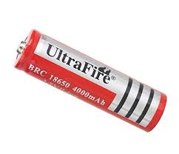
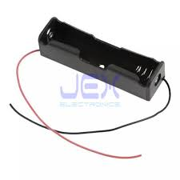

Since the output of the solar panel is not suitable to power the esp32 directly, I decided to utilize a small adjustable boost converter board that would boost the input to a regulated 5volts. In actuality, this did not regulate the voltage as I was hoping, but it did boost the voltage to 5 volts more or less and did not drop out until the input voltage was around 2.5 volts or so. The maximum I was able to measure in full sun was around 7 volts. The Huzzah32 board seemed to work just fine on this setup.
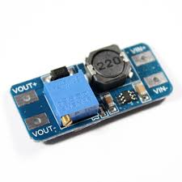

This board is available on Amazon at the link here; https://www.amazon.com/dp/B08R5LMQH1?psc=1&ref=ppx_yo2_dt_b_product_details
MT3608 DC-DC Boost Converter 2A Adjustable Step Up Module Voltage Regulator Board Input Voltage 2V-24V to 5V-28V Output Voltage (with USB Connector).
The ESP 32 that I chose for this project is the Adafruit HUZZAH 32 board. This is overkill for this small project and any number of microprocessors would be able to handle this as long as it had WiFi. This board has a few features that made it a very good choice for a solar project. First, is has very low current draw in deep sleep mode. It was about half of what the Wroom 32 DEVKITV1 board consumed. Second, It has an on-board lipo battery charge controller and a connector to plug in the battery. It also has a charging LED. And third, it has a builtin voltage divider to allow you to monitor it’s battery voltage. This eliminated a few parts. I had previously purchased this board and already had it on hand.
They are available here from Amazon; https://www.amazon.com/Adafruit-HUZZAH32-ESP32-Feather-Board/dp/B01NCRYHDL/ref=sr_1_4?keywords=huzzah32&qid=1638628519&s=electronics&sr=1-4

There is a lot of useful information on this board on the Adafruit website here; https://learn.adafruit.com/adafruit-huzzah32-esp32-feather

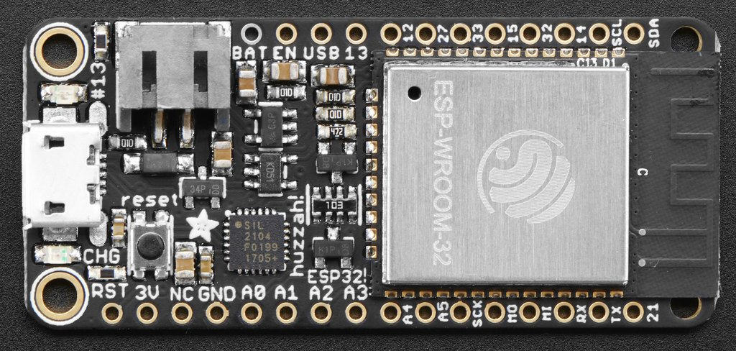
Adafruit Huzzah 32

Adding a capacitor and a couple of resistors for the voltage divider to monitor the solar panel output and I now had all the parts needed to proceed with the project. I then needed to develop the code for the ESP 32. I used the Arduino IDE software to write the code for this project. There were a few design goals for this part of the project. Being that this would be a battery powered solar project, one of the main concerns was the total current draw of the all the circuitry and whether the solar panel would be able to re-charge the battery during the day light hours Therefore, it was necessary to utilize the deep sleep mode of the ESP 32 to reduce current draw to a minimum. There is also the current draw of the LP sensor and the other circuitry. I used a VOM to measure the LP sensor current draw and found it to be ~3ma. In order to save as much power as possible during the deep sleep state, I decided to power the LP Sensor thru one of the GPIO pins on the ESP32. In the code, I set the pin up as an output and set it high just before reading the lp sensor voltage. Allowing for a small delay of around 100ms to stabilize the voltage before reading. I then set the pin low and set it as an input which uses less current.
I used the Power Profiler II kit developed by Nordic to measure the currents of the ESP 32 and to get a graph of the current draw over time of the ESP 32 sleeping and also waking up and performing the code instruction before going back to sleep. I chose to wake the processor up every 30 minutes and take the readings, send the data via MQTT and go back to sleep. I really could get by with taking readings at a much longer interval as the gas consumption should not change at any perceivable amount in 30 minutes. The Wroom 32 DEVKITV1 board that I first tried would not function correctly at sleep times over 30 minutes. I do not know why that was. Once the code was written, testing began. I was pleasantly surprised that the internal battery monitor worked flawlessly. The LP Gas sensor also worked perfect. I only had to adjust the formula slightly to get it to read what was actually showing on the gauge. The tricky part of this project, and where I spent the most time trying to calibrate was the voltage monitor of the solar panel. For some reason, this did not seem to follow the ease of other two measurements. I wound up adding a 1uf capacitor between the input pin that I used to read the voltage and ground. Basically adding it in parralel to the R2 resistor. This stabilized the readings but there seemed to be some inaccuracies between readings. At this point, I had the code so that the first thing that happened out of deep sleep was that it established a WiFI connection. This made the voltages fluctuate and dip slightly, loading down the solar panel output. I then changed the code so that it takes all readings before powering up the WiFi. This also helped stabilize the readings.

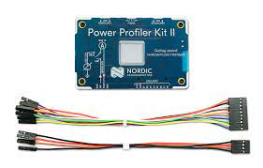

As shown in the graphic below, The Nordic Power Profiler II showed the current as follows;
Average current when in deep sleep 6.93ma with a max of 26.6ma.
Average current when awake was 100.61ma, averaged for the duration of ~4.12 seconds.
The maximum current during that period was 339.58ma.
This was about half of the current that the ESP32 DEVKITV1 board that I also tested. I am not sure why the deep sleep of the Huzzah 32 shows the current spikes around 26ma like it does. The ESP32 DEVKITV1 board did not have those.

This is the HUZZAH32 during deep sleep.
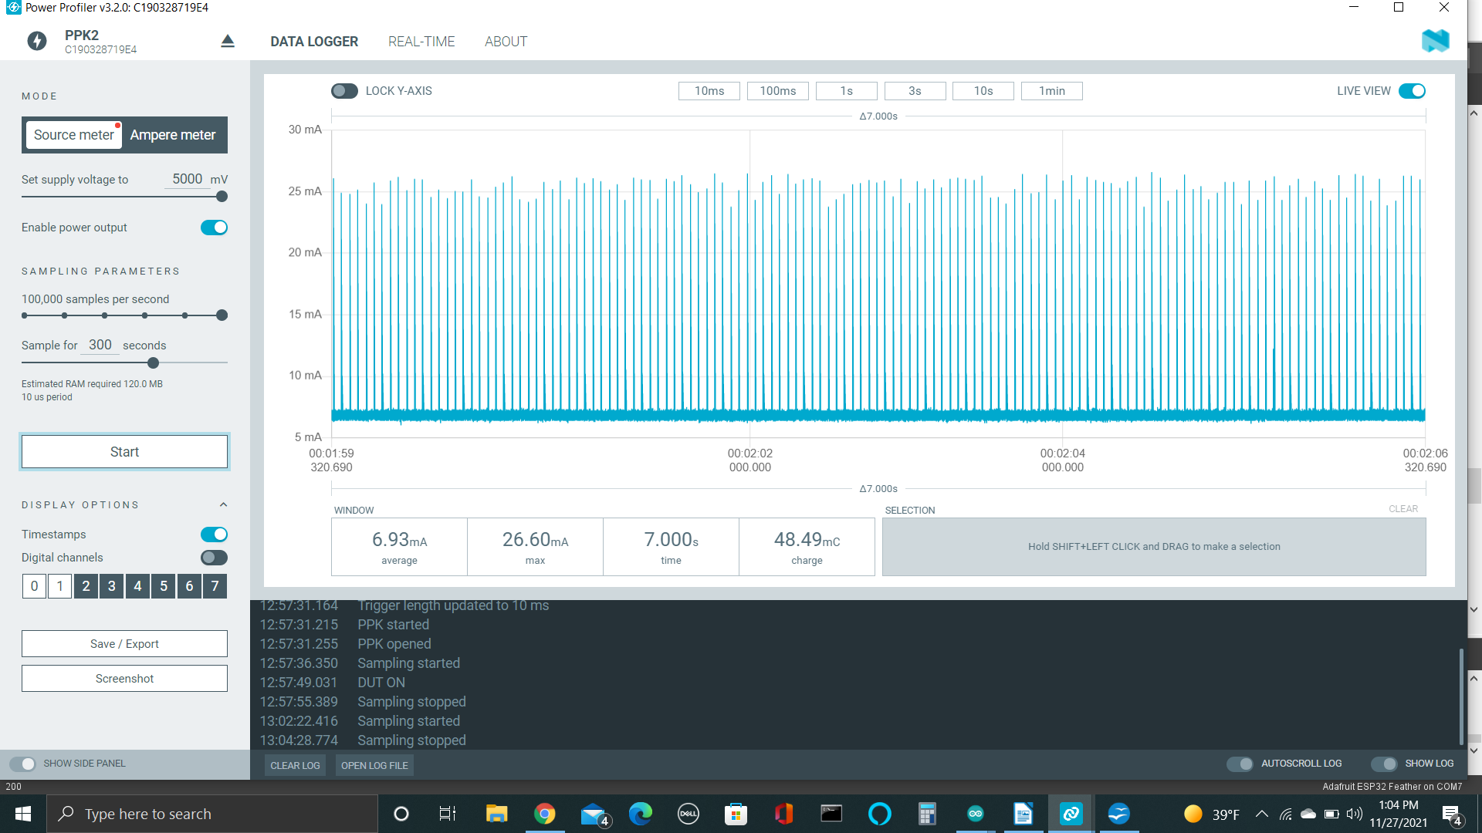

This is the HUZZAESP32 when it was awake and running the code.

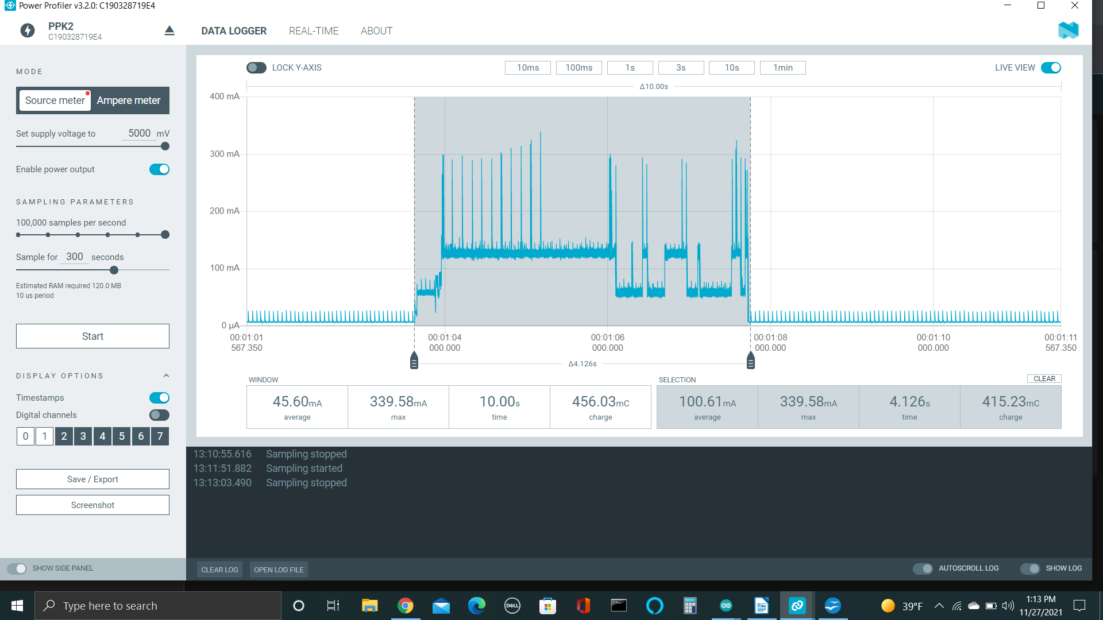
A shout out to G6EJD’s YouTube channel for this Excel solar battery calculator.
According to the solar charging spreadsheet, a 3000mah battery should remain charged for up to 17 days without any charging and is sustainable with solar charging from a .5w solar panel.
The next picture shows the solar charging calculations from the Solar Charging Battery Capacity Estimator Spreadsheet. I used a 3000mah battery capacity and a 6v .5w solar panel for the calculations instead of a 4000mah battery and a 1w solar panel. This shows a daily surplus of about 360 mah.

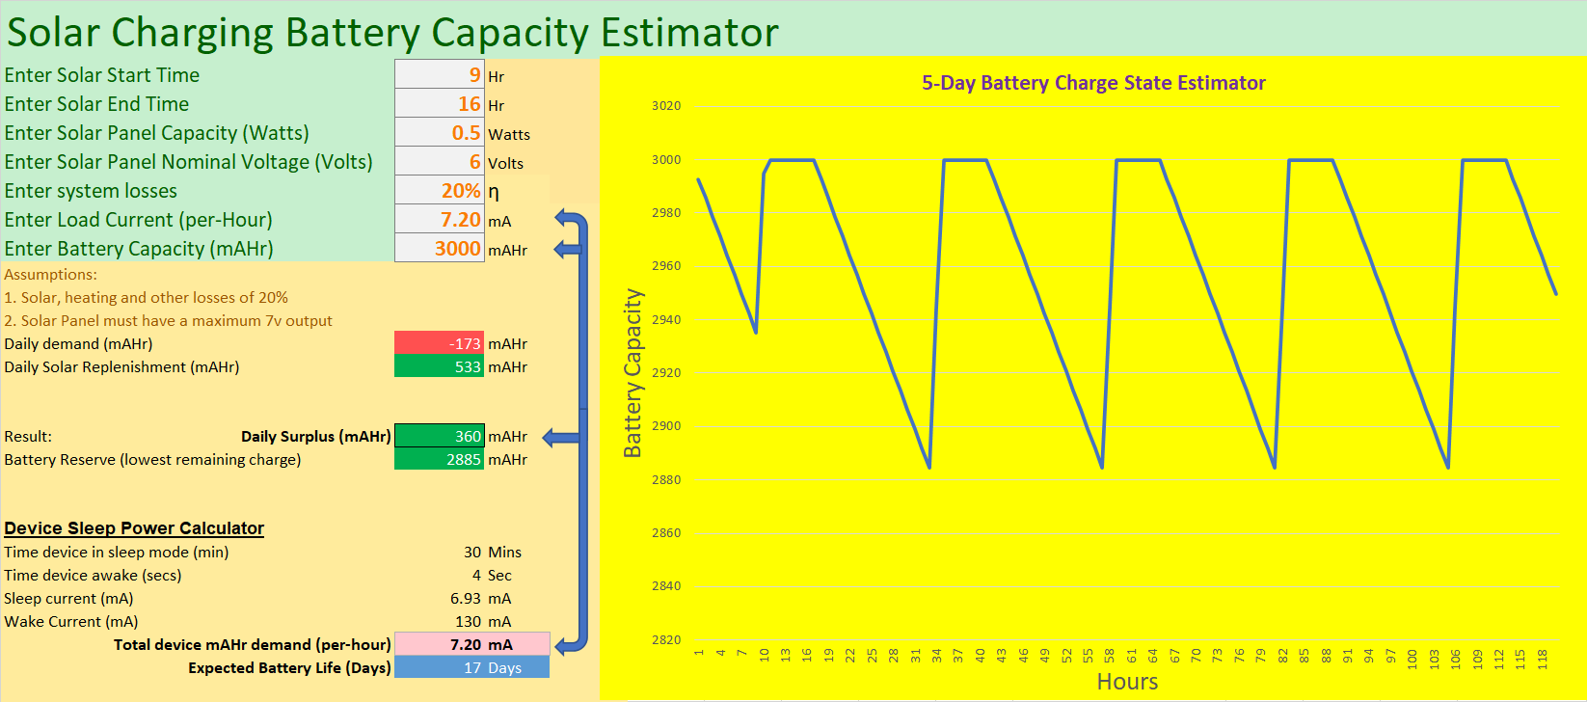

I also want to be able to monitor the battery voltage so I can tell how well the solar charger is functioning. Even though there is a 3.3v voltage regulator on the ESP32 board that will allow a 5v input, the ESP32 chip runs on 3.3v and as such can only tolerate 3.3v on the pins. In order to monitor higher voltages, a voltage divider must be used to get the voltage down to a level suitable for the ESP32. Luckily, the Huzzah 32 was designed with an internal voltage divider connected to Analog input A13. If you use a different board and need help with the voltage divider, I used a combination of YouTube videos and a website to calculate the two resistors needed for the voltage divider to monitor the solar panel output. The YouTube videos are from G6EJD https://www.youtube.com/watch?v=gcbzdtRmYrM and the voltage divider calculator is here; https://ohmslawcalculator.com/voltage-divider-calculator . This should take higher voltages at the top of the resistors and output 3.3v at the junction of the two resistor. This will need to be calibrated in the code so that it is accurate. It is stated in the technical notes for the ESP32 that each chip will be slightly different. The next screenshot shows the website calculations for the resistors if you intend on 4.2 volts max input.
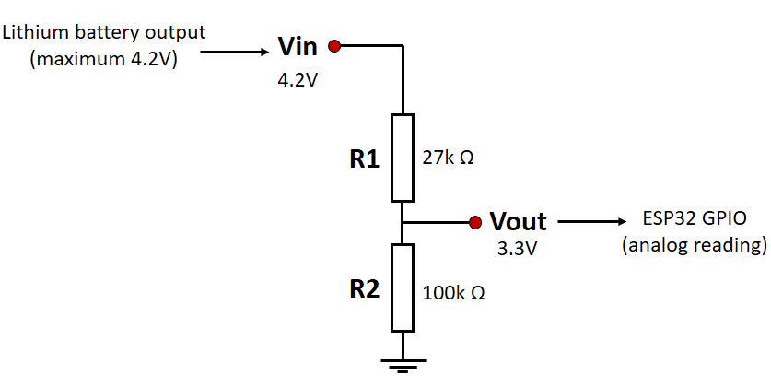

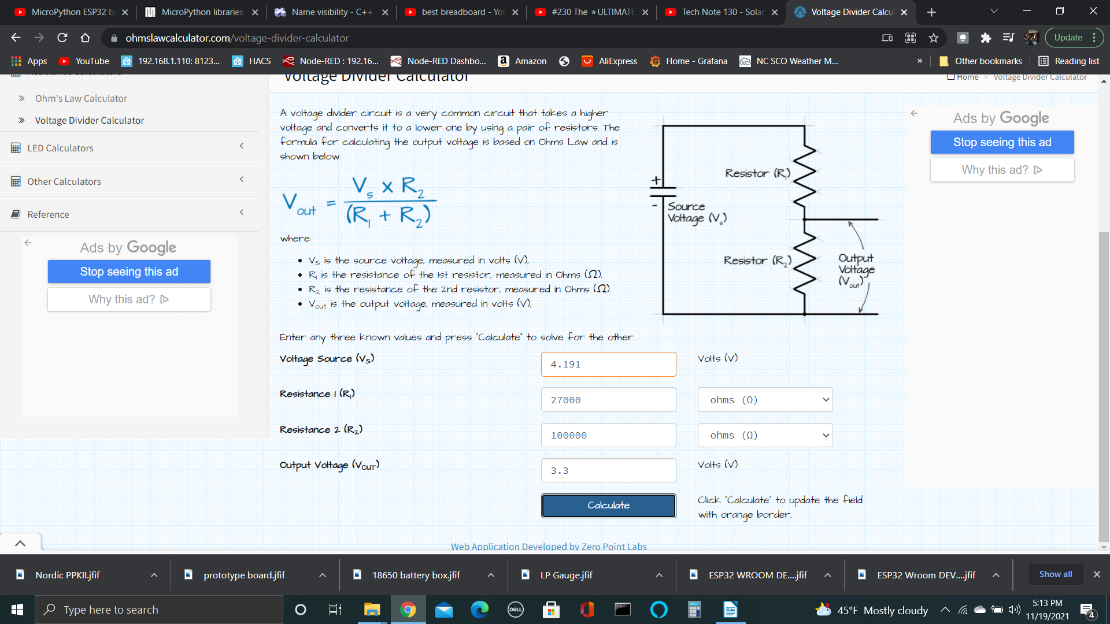
Another design goal was to be able to transmit the LP gas level and battery measurements via MQTT messages back to my raspberry pi that is running Home Assistant and Node Red. From there I can setup automations that will send email or sms messages when the readings are getting low. I will also store the data in InfluzDB and graph it in grafana. I also increment a “bootcount” variable each time the unit wakes up out of deep sleep. This also gets sent in an mqtt message.

The following diagram shows all the connections for the project.

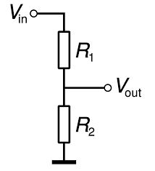

I decided to add the extra resistors to make a voltage divider so that I can measure the solar panel voltage output. This will be measured on GPIO 36 (SOLARPIN). I calculated the resistors for an 8.8v max to yield 3.3v at the junction. These resistors were R1 200K and R2 120K. I calibrated the formula in software by measuring the solar panel output voltage with a VOM and calibrating the formula to get the correct readings. The formula is; solarvoltage = (rawsolarlevel/4095) * 8.8. It would not be very easy to go back and change resistors at this point if it needs more headroom in the upper range.
After finishing up all the soldering and connections, and getting sensors setup and working in Home Assistant, it was time to test it out in full sun and see how the solar performs. The following picture shows the test setup I had to monitor the battery voltage as it was charging and in deep sleep mode. The battery voltage stays at ~4.1 volts on a sunny day, and dips to ~4 volts over night. During one of the over night tests, I had the deep sleep time set to 1 minute. The battery voltage dipped to ~3.9 volts. The solar panel voltage changes with the amount of sun and was mostly in the 6 – 7 volt range when in full sun and the battery fully charged and the processor in deep sleep.

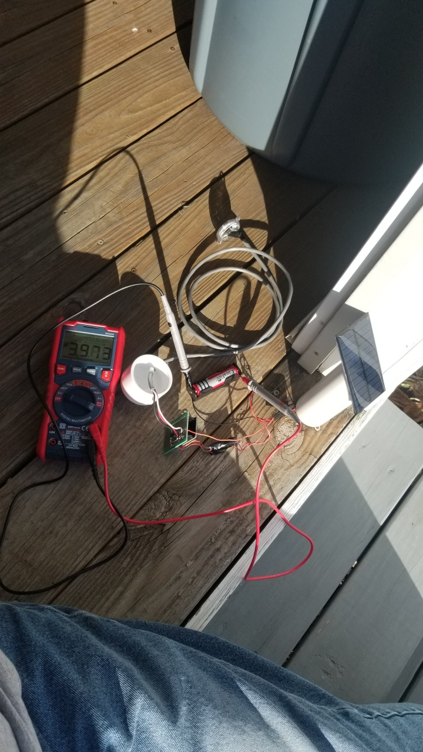

To house the circuitry, I cut a section of the 2” PVC pipe to a length of about 8”. I cut one end of the pipe at a 45 degree angle. I then used silicon to glue the solar panel to the PVC pipe being careful that there were no places where a leak could occur. I mounted a magnet to the outside of a 2” end cap by drilling a small hole and attaching it with a screw. This end cap with the magnet will hold the completed unit to the metal LP tank. I drilled a ¼” hole into the side of the end cap to allow the entry of the cable coming from the LP gas sensor. All the electrical components were taped to prevent short circuits then everything was placed inside the PVC pipe and the end cap slid over the pipe using a friction fit only, no glue. All that was left was to replace the gauge on the tank with the new gauge by removing the two small screws that were holding the gauge in place. I then stuck the assembled unit to the tank and the magnet held it in place. As an after thought, I though about using a propane sensor that could be used to sniff for leaks.

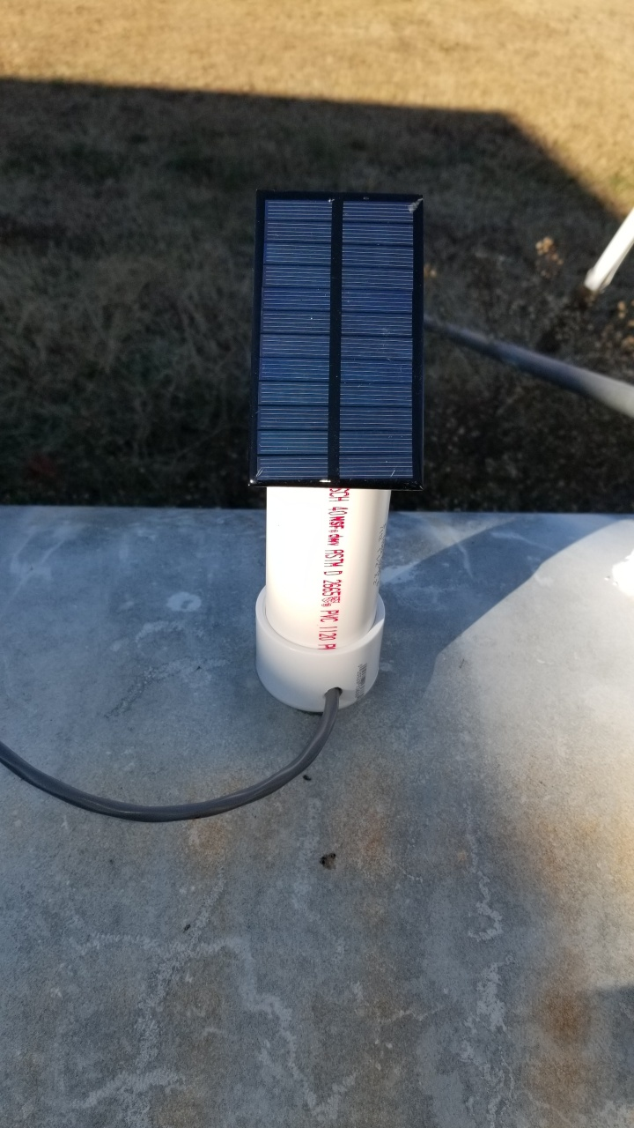

PARTS LIST

1 Adafruit HUZZAH 32 (ESP32)
1 set of header pins (used to mount ESP board to the perf board)
1 Adjustable boost converter with micro USB inputPin
1 solar panel 6V 1W (size is 110mm x 60mm or 4.3” x 2.3”
1 18650 Li-ion battery 4000mah
1 18650 battery box
1 200K ohm resistor
1 120K ohm resistor
1 1uf capacitor
1 perf board
1 8” section on 2” PVC pipe
1 end cap for 2” pvc pipe
1 magnet (used to secure the pipe to the LP tank)
1 small amount of silicon adhesive (used to attach and seal the solar panel to the pipe)
1 electrical tape (used to insulate the boards from each other inside the pipe)

Here is the code for this project.

/* XXXXXXXXXXXXXXXXXX ESP32_LP_GAS_SENSOR_MQTT Project - 11/27/2021 XXXXXXXXXXXXXXXXXXXXX
This sketch will use an Adafruit HUZZAH32 board and connect it to your SSID and MQTT server.
It blinks the BUILTIN LED until WIFI connects and then remains on until the entire sketch is complete, then it turns off.
It will turn on SENSORPOWER pin GPIO21 high to power the LP gas sensor which draws 3ma.
It reads analog voltage values from a LPGAS sensor on pin GPIO39 (LPLEVELPIN).
It maps the raw data to a range of 0 to 100 and prints it to the serial monitor.
It publishes the LPGAS level to a topic of "sensor/lpgassensor/lplevel.
It monitors the solar panel voltage on pin GPIO36 (SOLARPIN) thru a 2-resistor voltage divider made of 200K and 120K resistors.
It monitors the supply voltage thru a 2-resistor voltage divider built in to analog input 13. It must be multiplied by a factor of 2.
See the OHMS law calculator at https://ohmslawcalculator.com/voltage-divider-calculator. The pre-calculated values are shown in the next few lines.
8.8V = 200k R2 = 120k equation is float voltage=(float)analogRead(36)/4095*8.8) This had to be adjusted slightly to get an accurate reading.
It prints the raw voltages and the calibrated voltage data to the serial monitor.
It publishes the solar output level to an MQTT topic of "sensor/lpgassensor/solarlevel"
It publishes the battery voltage level to an MQTT topic of "sensor/lpgassensor/batterylevel"
It keeps up with the number of times it has woken up with the variable "bootcount" that is stored in RTC memory.
It publishes this bootcount to a topic of "sensor/lpgassensor/bootcount"
It can send an MQTT message of "LP GAS Sensor Battery level is low!" if the level goes below a specified level (3.6v).
It can send an MQTT message of "LP GAS level is low!" if the level goes below a specified level (30%).
It can send an MQTT message of "LP GAS Sensor Solar voltage is low!" if the level goes below a specified level (3v).
It goes into deep sleep mode for a period of time after all commands have been executed.
It will then wake up and repeat this process on a time interval set by the Deepsleeptime. In this case it is 30 minutes.
The total time it takes to wake up and transmit the data is roughly 3 to 5 seconds.
It draws roughly 6ma when in deep sleep. It draws an average of 130MA for the time it is awake.
*/

#include <Arduino.h>
RTC_DATA_ATTR int bootcount = 0;

#include <WiFi.h>
#include <PubSubClient.h>
#define Deepsleeptime 30 // Define a variable for the deep sleep time and give it a value in minutes
//IPAddress local_IP(192,168,1,123); //use these 4 lines if you wish to have a static IP address
//IPAddress gateway(192,168,1,254);
//IPAddress subnet(255,255,255,0);
//IPAddress primaryDNS(8,8,8,8);

void goToDeepSleep() // setup the deep sleep function to be called later at the end of the code.
{
Serial.print("BYE_BYE - Going to sleep now for ");
Serial.print(Deepsleeptime);
Serial.print(" minutes!");
esp_sleep_enable_timer_wakeup(Deepsleeptime * 60000000);
esp_deep_sleep_start();
}

// Update these with values suitable for your network.
const char* ssid = "your network";
const char* password = "your password";
const char* mqtt_server = "192.168.1.110";
float rawbatterylevel = 0.0;
float batterylevel = 0.00;
int lplevel = 0;
int rawlplevel = 0;
float rawsolarlevel = 0.0;
float solarvoltage = 0.0;

#define LPLEVELPIN 39 // select the input pin for the LP sensor. analog A3 input
/#define VOLTAGE_PIN 35 // select the input pin for the battery monitor (VP). Analog input A13 input, reads 1/2 of battery voltage.
#define SENSORPOWER 21 // select the output pin to power the sensor which draws 3 ma.
#define SOLARPIN 36 //select the input pin for the solar panel voltage monitor. Analog input A4.
#define LED_BUILTIN 13 // connected to the red LED

WiFiClient LPGAS_SENSOR;
PubSubClient client(LPGAS_SENSOR);

void setup_wifi() // We start by connecting to a WiFi network
{

Serial.begin(115200);
Serial.println("");
Serial.print("Connecting to WiFi SSID ");
WiFi.mode(WIFI_STA);
Serial.println(ssid);
// if(!WiFi.config(local_IP, gateway, subnet, primaryDNS)) // use these 4 lines if you wish to use the static IP address
// {
// Serial.println("STA failed to configure");
// }
WiFi.begin(ssid, password);
//pinMode(LED_BUILTIN, OUTPUT);
while (WiFi.status() != WL_CONNECTED) {
Serial.print(".");
digitalWrite(LED_BUILTIN, HIGH);
delay(50);
digitalWrite(LED_BUILTIN, LOW);
delay(50);
}
//pinMode(LED_BUILTIN, INPUT);
pinMode(SOLARPIN, INPUT);
Serial.println("Ready");
Serial.println("");
Serial.println("WiFi connected!");
Serial.print(" IP address: ");
Serial.println(WiFi.localIP());
}

void reconnect() // Loop until we're reconnected
{
while (!client.connected()) {
Serial.println("Attempting MQTT connection...");
// Attempt to connect
if (client.connect("LP_Gas_Sensor")) {
Serial.println(" Connected as device client LP_Gas_Sensor.");
Serial.println("");
digitalWrite(LED_BUILTIN, HIGH);
} else {
Serial.print("failed, rc=");
Serial.print(client.state());
Serial.println(" try again in 2 seconds");
// Wait 2 seconds before retrying
delay(2000);
}
}
}
void setup() {

Serial.begin(115200);
client.setServer(mqtt_server, 1883);
++bootcount;
Serial.println("");
Serial.println("");
Serial.println("................LP GAS SENSOR........11/27/2021........");
Serial.println("");
Serial.println("The bootcount is " + String(bootcount));
}

void loop() {

pinMode(LED_BUILTIN, OUTPUT);
pinMode(SENSORPOWER, OUTPUT);
Serial.println("");
Serial.println("Reading sensor data...");

// These next lines will read the LP Gas level voltage
digitalWrite(SENSORPOWER, HIGH); //This powers up the LP sensor on GPIO 21
delay(5);
rawlplevel = analogRead(LPLEVELPIN); // GPIO 39 A3
digitalWrite(SENSORPOWER, LOW); //This turns off the power to the LP sensor on GPIO 21
pinMode(SENSORPOWER, INPUT);
Serial.print("The raw LP level is ");
Serial.println(rawlplevel);
lplevel = map(rawlplevel, 0, 4095, 0, 100)+ 2; //
Serial.print("The LP Gas level is ");
Serial.print(lplevel);
Serial.println("%");

// These next line will read the battery voltage and print it to serial monitor

rawbatterylevel = analogRead(VOLTAGE_PIN); // GPIO35 Analog inout A13 which is an internal pin with voltage divider.
Serial.print("The raw battery level is ");
Serial.println(rawbatterylevel);
batterylevel = (rawbatterylevel/4095) * 3.3 * 2; //adjust the calibration number to match VOM readings of battery.
Serial.print("The battery supply voltage is ");
Serial.print(batterylevel);
Serial.println(" Volts");

// These next line will read the solar panel output voltage and print it to serial monitor
delay(5);
rawsolarlevel = analogRead(SOLARPIN); // GPIO36 or analog input A4
Serial.print("The raw solar level is ");
Serial.println(rawsolarlevel);
solarvoltage = (rawsolarlevel/4095) * 6.6; //the resistors were both 200k. Adjust the calibration number to match VOM readings of solar output.
Serial.print("The solar output voltage is ");
Serial.print(solarvoltage);
Serial.println(" Volts");

setup_wifi();

if (!client.connected()) {
reconnect();
}
digitalWrite(LED_BUILTIN, HIGH); //This turns on the built in LED.
Serial.println("Sending MQTT messages.");

if (solarvoltage <= 3)// sets the level for the low solar output message to be sent.
{
Serial.println("SOLAR OUTPUT VOLTAGE IS LOW!");
//client.publish("sensor/lpgassensor/solarvoltage", String("LP GAS Sensor Solar output voltage is low!").c_str()); // Publish the low solar output voltage message value to MQTT
}
if (batterylevel <= 3.6)// sets the level for the low battery message to be sent.
{
Serial.println("BATTERY VOLTAGE IS LOW!");
//client.publish("sensor/lpgassensor/batterylevel", String("LP GAS Sensor battery level is low!").c_str()); // Publish the low battery message value to MQTT
}
if (lplevel <= 30)
{
Serial.println("LP GAS LEVEL IS LOW!");
client.publish("sensor/lpgassensor/lplevel", String("LP GAS level is low!").c_str()); // Publish the low las level message value to MQTT
}
delay(5);
client.publish("sensor/lpgassensor/lplevel", String(lplevel).c_str(),1); // Publish the LP GAS Level to MQTT
delay(5);
client.publish("sensor/lpgassensor/bootcount", String(bootcount).c_str(),1); // Publish the bootcount to MQTT
delay(5);
client.publish("sensor/lpgassensor/solarvoltage", String(solarvoltage).c_str(), 1); // Publish the solar voltage value to MQTT
delay(5);
client.publish("sensor/lpgassensor/batterylevel", String(batterylevel).c_str(), 1); // Publish the batterylevel value to MQTT
Serial.println("");
digitalWrite(LED_BUILTIN, LOW); //This turns off the built in LED.

goToDeepSleep(); // comment out this line for testing
//delay(3000); // comment out this line for testing
return;
}

